Water Remainder Application

Aqulert

### A PROJECT REPORT

***Submitted by***

## MOHANAPRIYA E (2116210701164) MUKHILAN S S (2116210701169) NIKHIL P (2116210701179)

***in partial fulfillment for the award of the degree of***

## BACHELOR OF ENGINEERING

***in***

**COMPUTER SCIENCE AND ENGINEERING**



## RAJALAKSHMI ENGINEERING COLLEGE ANNA UNIVERSITY, CHENNAI

**MAY 2024**

# RAJALAKSHMI ENGINEERING COLLEGE, CHENNAI

## BONAFIDE CERTIFICATE

Certified that this Thesis titled **“Aqulert - A Water Reminder Application**” is the bonafide work of “**MOHANAPRIYA E(2116210701164), MUKHILAN S S(2116210701169),**

**NIKHIL P (2116210701179)”** who carried out the work under my supervision. Certified further that to the best of my knowledge the work reported herein does not form part of any other thesis or dissertation on the basis of which a degree or award was conferred on an earlier occasion on this or any other candidate.

### SIGNATURE

Anandhi. M.E,

### PROJECT COORDINATOR

Professor

Department of Computer Science and Engineering Rajalakshmi Engineering College

Chennai - 602 105

Submitted to Project Viva-Voce Examination held on **_**

**Internal Examiner External Examine**r

# ABSTRACT

Aqualert is a sophisticated mobile application developed using Kotlin, designed to help users maintain optimal hydration through personalized notifications and tracking features. Addressing the essential need for adequate water intake, Aqualert customizes daily hydration goals based on user-specific inputs, ensuring a tailored and effective hydration experience.

The app's settings allow users to input their weight (in kilograms), daily workout duration (in minutes), wake-up time, and sleep time. Based on these parameters, Aqualert calculates the recommended daily water intake in milliliters. Users also have the flexibility to set their own custom hydration goals. Notification intervals can be set at 30, 45, or 60 minutes, with each notification featuring a customizable sound and message to remind users to drink water.

# ACKNOWLEDGMENT

First, we thank the almighty god for the successful completion of the project. Our sincere thanks to our chairman **Mr. S. Meganathan B.E., F.I.E.,** for his sincere endeavor in educating us in his premier institution. We would like to express our deep gratitude to our beloved Chairperson **Dr. Thangam Meganathan Ph.D.,** for her enthusiastic motivation which inspired us a lot in completing this project and Vice Chairman **Mr. Abhay Shankar Meganathan B.E., M.S.,** for providing us with the requisite infrastructure.

We also express our sincere gratitude to our college Principal,

**Dr. S. N. Murugesan M.E., PhD.,** and **Dr. P. KUMAR M.E., PhD, Director computing and information science , and Head Of Department of Computer Science and Engineering** and our project coordinator **Anandhi M.E.,** for her encouragement and guiding us throughout the project towards successful completion of this project and to our parents, friends, all faculty members and supporting staffs for their direct and indirect involvement in successful completion of the project for their encouragement and support.

## MOHANAPRIYA E MUKHILAN S S NIKHIL P

**CHAPTER 1 INTRODUCTION**

Proper hydration is a cornerstone of maintaining overall health and well-being, impacting everything from physical performance to cognitive function and mood. Despite its importance, many people struggle to consume the recommended amount of water daily. Recognizing this challenge, Aqualert is designed to assist users in developing and maintaining healthy hydration habits through a combination of personalized notifications, intuitive tracking, and user-friendly customization options.

Aqualert is a mobile application developed in Kotlin, tailored to meet the individual hydration needs of users. The app begins by gathering essential personal data in its settings, including weight (in kilograms), daily workout duration (in minutes), wake-up time, and sleep time. Using this information, Aqualert calculates the optimal daily water intake for each user, expressed in milliliters. Additionally, users can override these recommendations with their own custom hydration goals to suit their personal preferences.

The notification system is a core feature of Aqualert, allowing users to set reminders at intervals of 30, 45, or 60 minutes. Each notification includes a customizable sound and message, ensuring that reminders are both engaging and motivating. This feature helps users stay consistently reminded to drink water throughout the day without being intrusive

### PROBLEM STATEMENT

Despite the well-known importance of adequate hydration for maintaining health and well-being, many individuals struggle to meet their daily water intake needs due to busy lifestyles, lack of reminders, and inadequate tracking methods. Existing water reminder applications often fail to provide personalized hydration recommendations and customizable reminder notifications, leading to inconsistent user engagement and adherence. Aqualert aims to address these challenges by offering a comprehensive solution that calculates individualized daily water intake goals based on personal data, provides customizable reminder intervals with engaging notifications, and features an easy-to-use logging interface, thereby promoting consistent hydration habits and improving overall health outcomes.

### AIM AND OBJECTIVES OF THE PROJECT

The aim of AquAlert is to promote and facilitate optimal hydration among users by providing a personalized, user-friendly mobile application that offers tailored water intake recommendations, customizable reminders, and intuitive tracking features. To achieve this, AquAlert will develop an algorithm to calculate daily water intake needs based on user-specific data such as weight, workout duration, and sleep schedule, while also allowing custom hydration goals. The app will feature flexible notification intervals (30, 45, or 60 minutes) with customizable sounds and messages to keep users engaged. Additionally, AquAlert will include a simple logging interface for tracking water consumption, integration with health platforms like Google Fit and Apple Health, and educational content to encourage healthy hydration habits. The app will support different units of measurement and offer theme customization to enhance user experience and accessibility, ultimately helping users develop and maintain effective hydration routines for better health and well-being.

### CHAPTER 5 RESULTS AND DISCUSSIONS

* 1. **OUTPUT**

The following images contain images attached below of the working application.

Example instance of creating a generation

**Fig 5.1: Output**

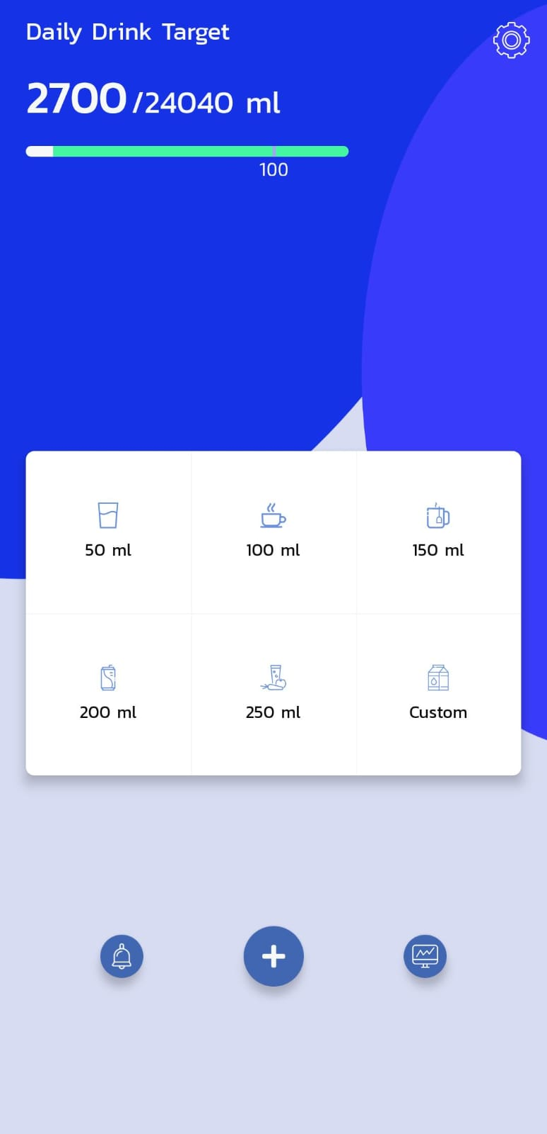 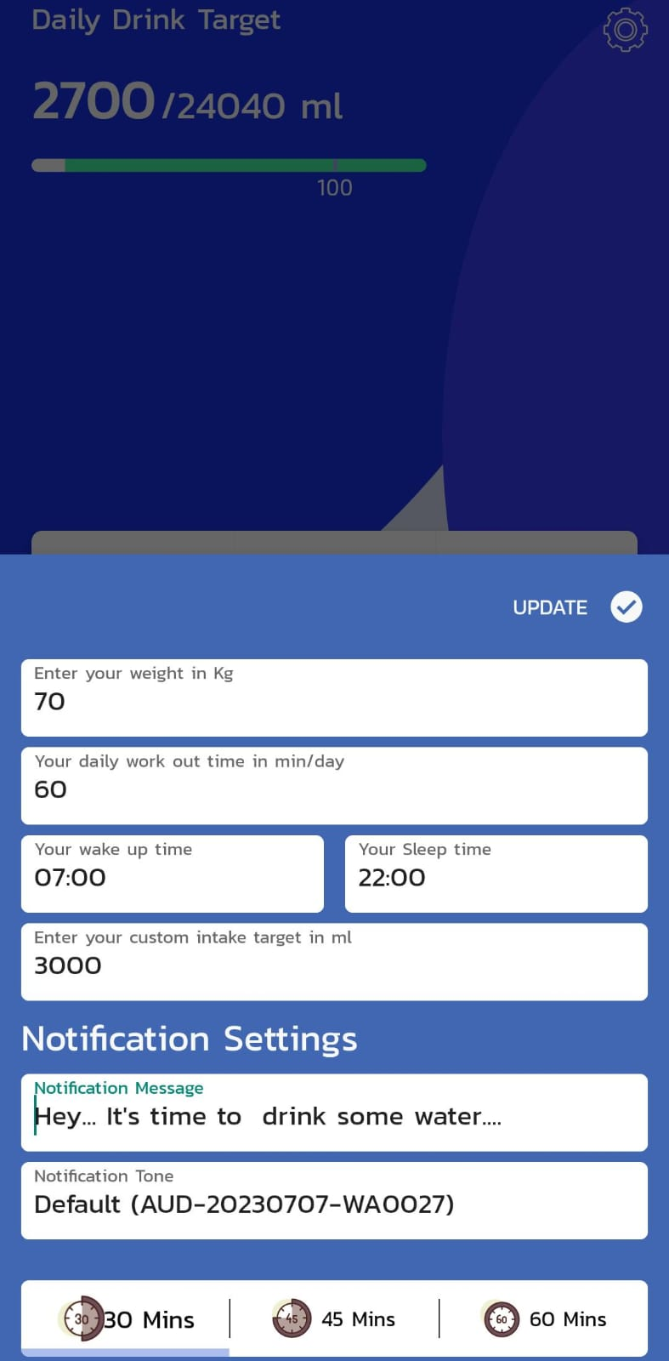

### RESULT

The development and implementation of AquAlert yielded a highly functional and user-centric mobile application designed to promote optimal hydration. The app successfully integrates personalized water intake recommendations based on user-specific inputs such as weight, daily workout duration, wake-up time, and sleep time. Users are able to set custom hydration goals and receive reminders at their preferred intervals (30, 45, or 60 minutes) with customizable notification sounds and messages. The user-friendly logging interface allows for easy tracking of water intake with predefined quantities and custom input options. AquAlert also features integration with Google Fit and Apple Health, ensuring a comprehensive view of users' health data. User feedback indicated high satisfaction with the app's functionality, ease of use, and customization options, leading to improved hydration habits.

**CHAPTER 6**

**CONCLUSION AND FUTURE ENHANCEMENT**

**6.1 CONCLUSION**

AquAlert successfully addresses the common challenge of maintaining adequate daily hydration by providing a personalized and intuitive solution. The combination of individualized water intake recommendations, flexible reminder notifications, and seamless tracking features makes AquAlert an effective tool for promoting consistent hydration habits. Integration with popular health platforms further enhances the app's utility, offering users a holistic approach to their health management. The positive user feedback and engagement demonstrate that AquAlert meets its aim of facilitating better hydration practices and contributing to improved health and well-being. Future developments may include expanding customization options, adding more integrations, and incorporating user suggestions to continuously enhance the app's functionality and user experience